EXPERIMENT-11
Link Jira tasks with Confluence to streamline task tracking and progress monitoring for the Library Management System development.
Step 1: Login into jira account and create a scrum
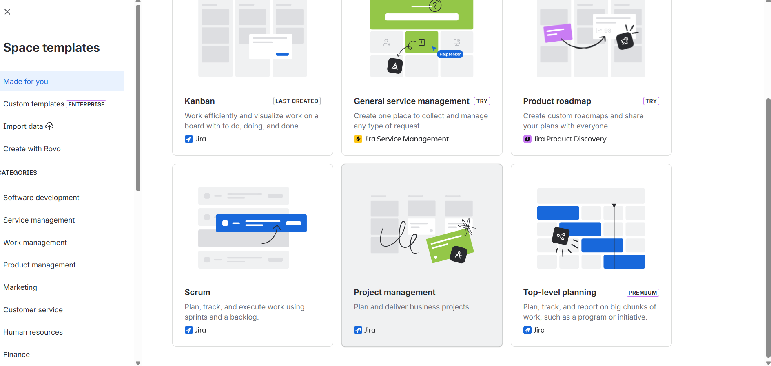

Step 2:Create a name of the project and select Company managed work
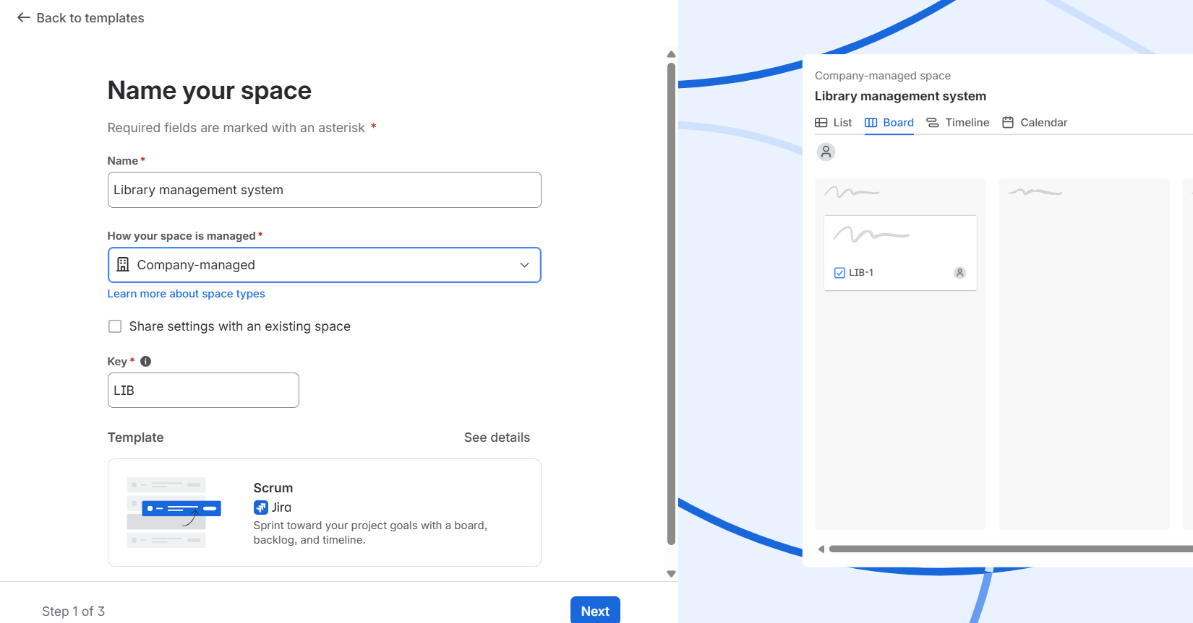

Step 3:Open the backlog and create sprint and assign tasks
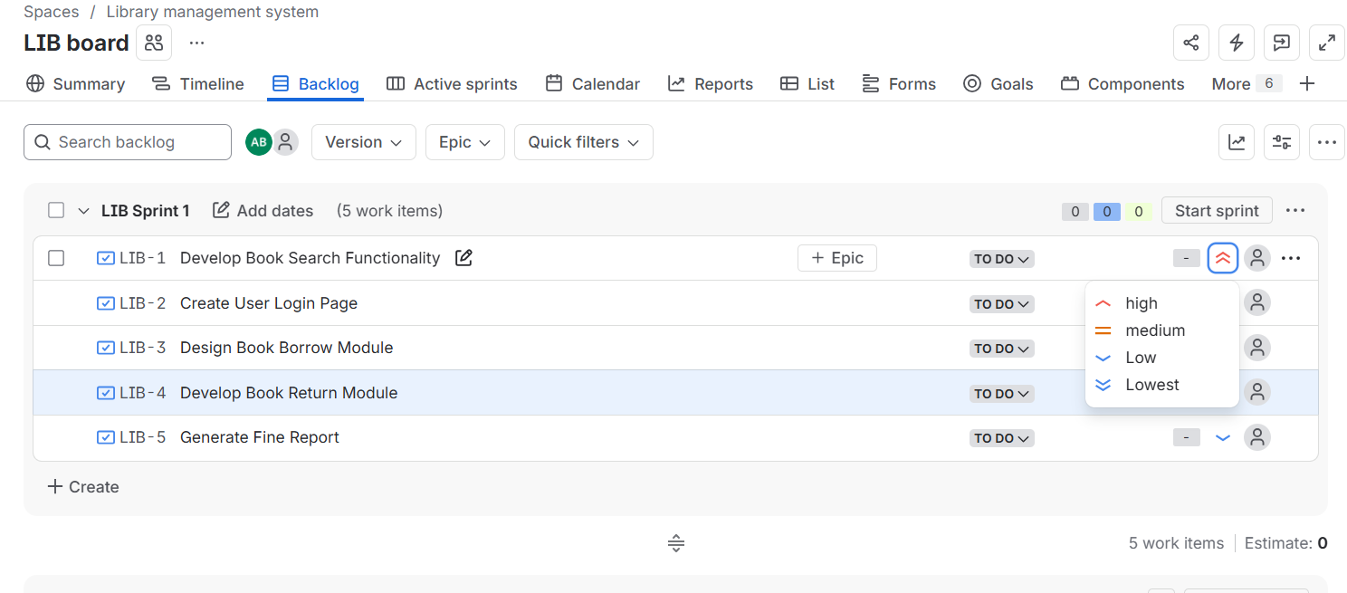
Step 4: :We can verify all task in scrum board
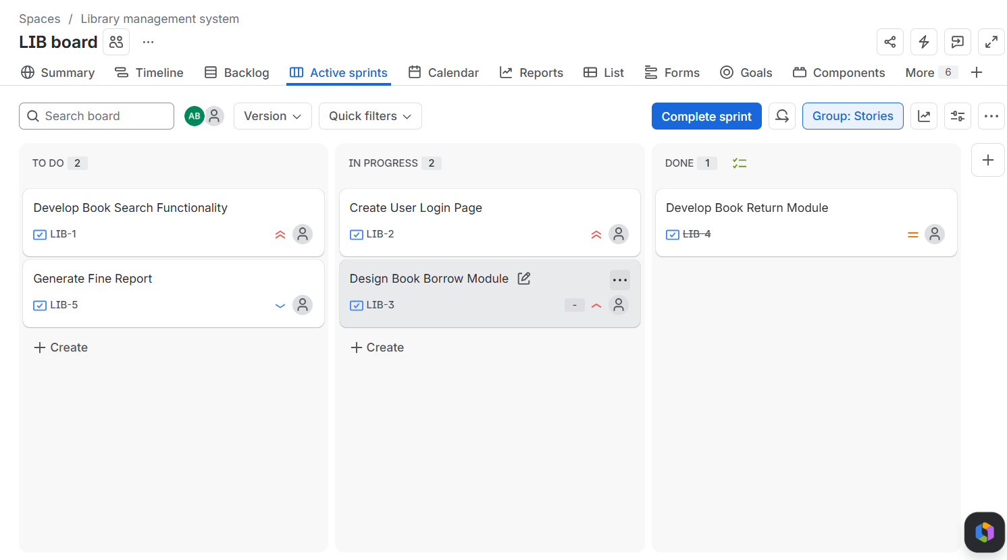
Step 5:create a Confluence page and insert workitems
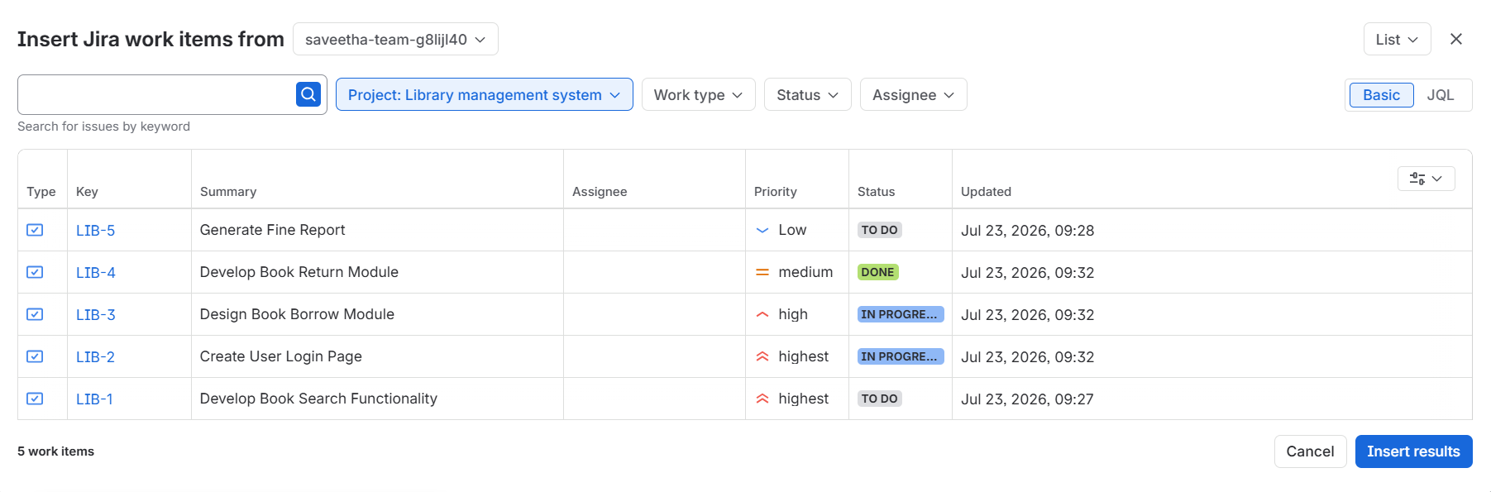

Step 6:sprint progress and connect jira to confluence
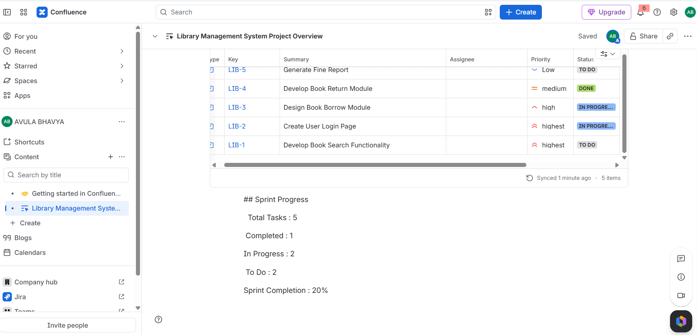

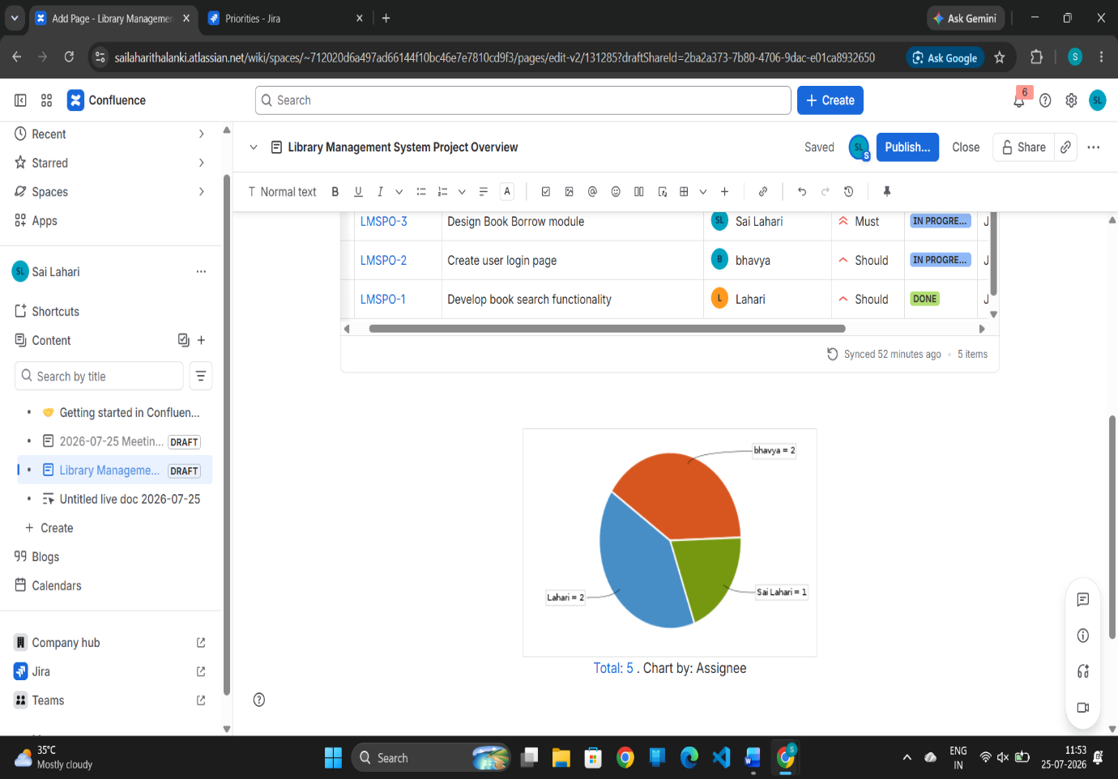
Step 7:summary
